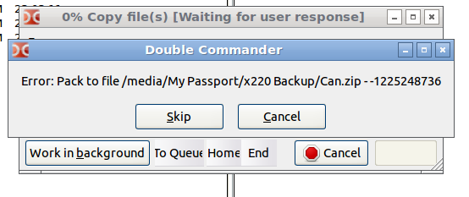
Screenshot:

Steps to reproduce:
- Under File Manager view, create a new archive using Atl + F5
- Select rar checkbox
- Uncheck rar checkbox (You realize, you are better off with the default ZIP)
- Select Ok to pack and you get the above dialog box

